1).

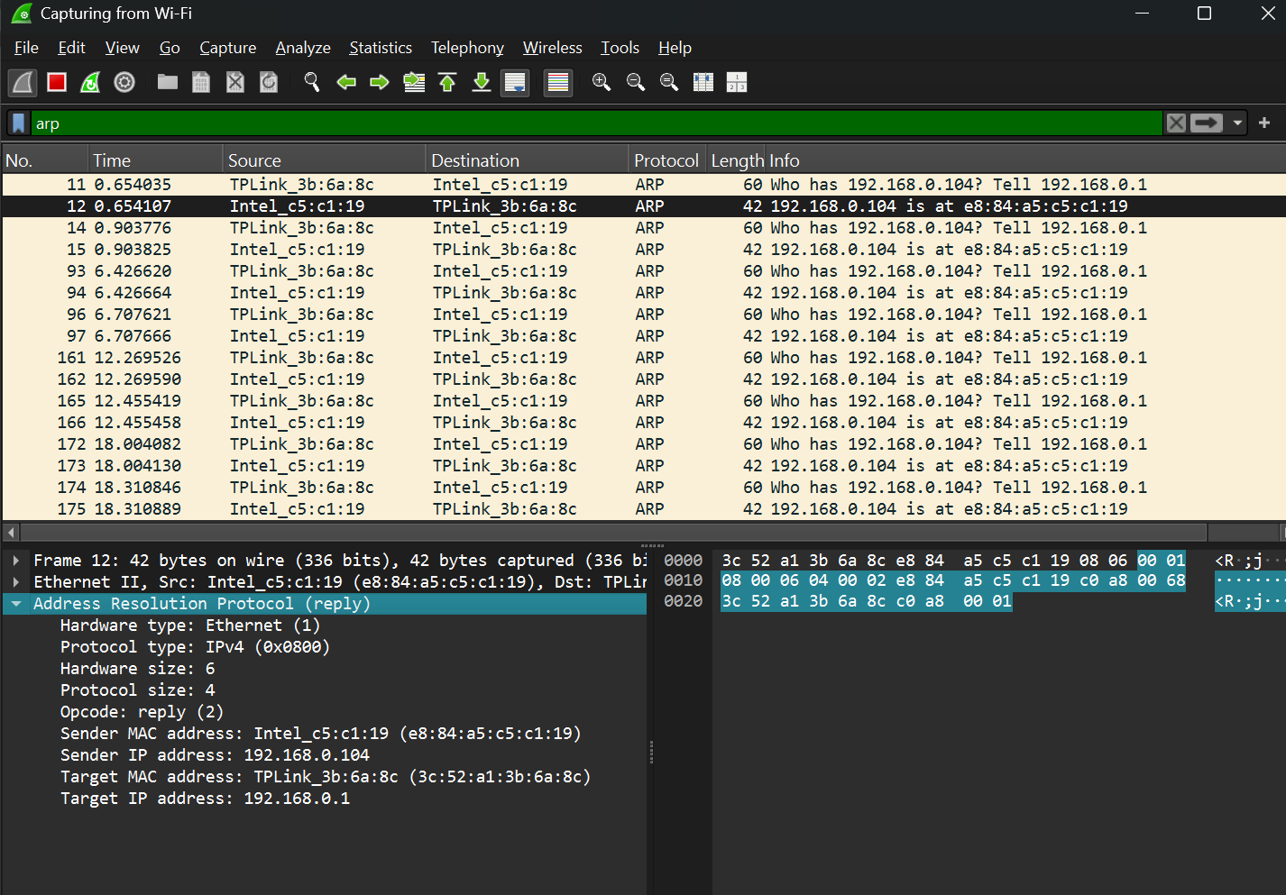

2).

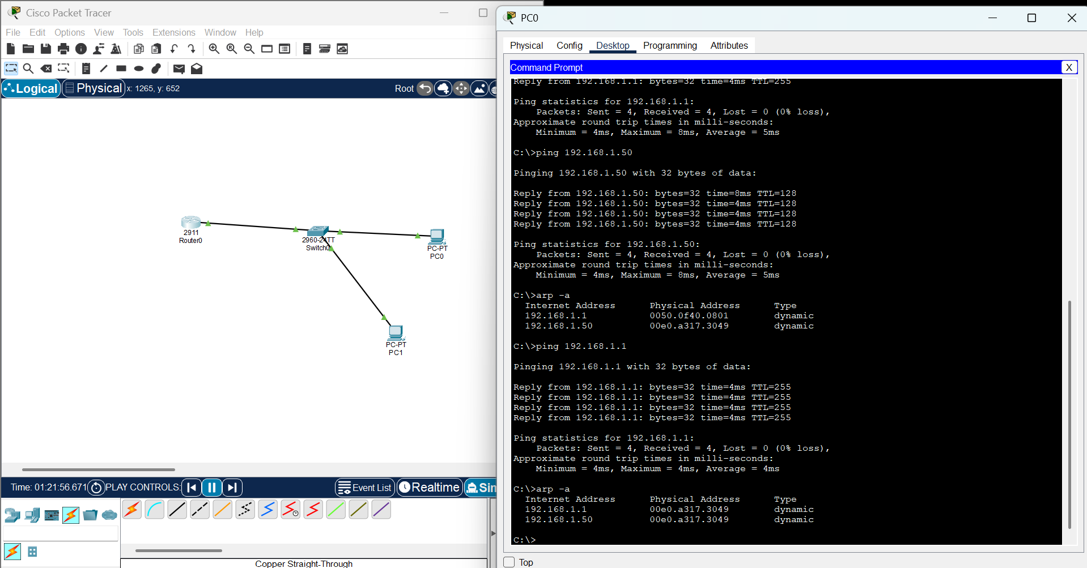

3).

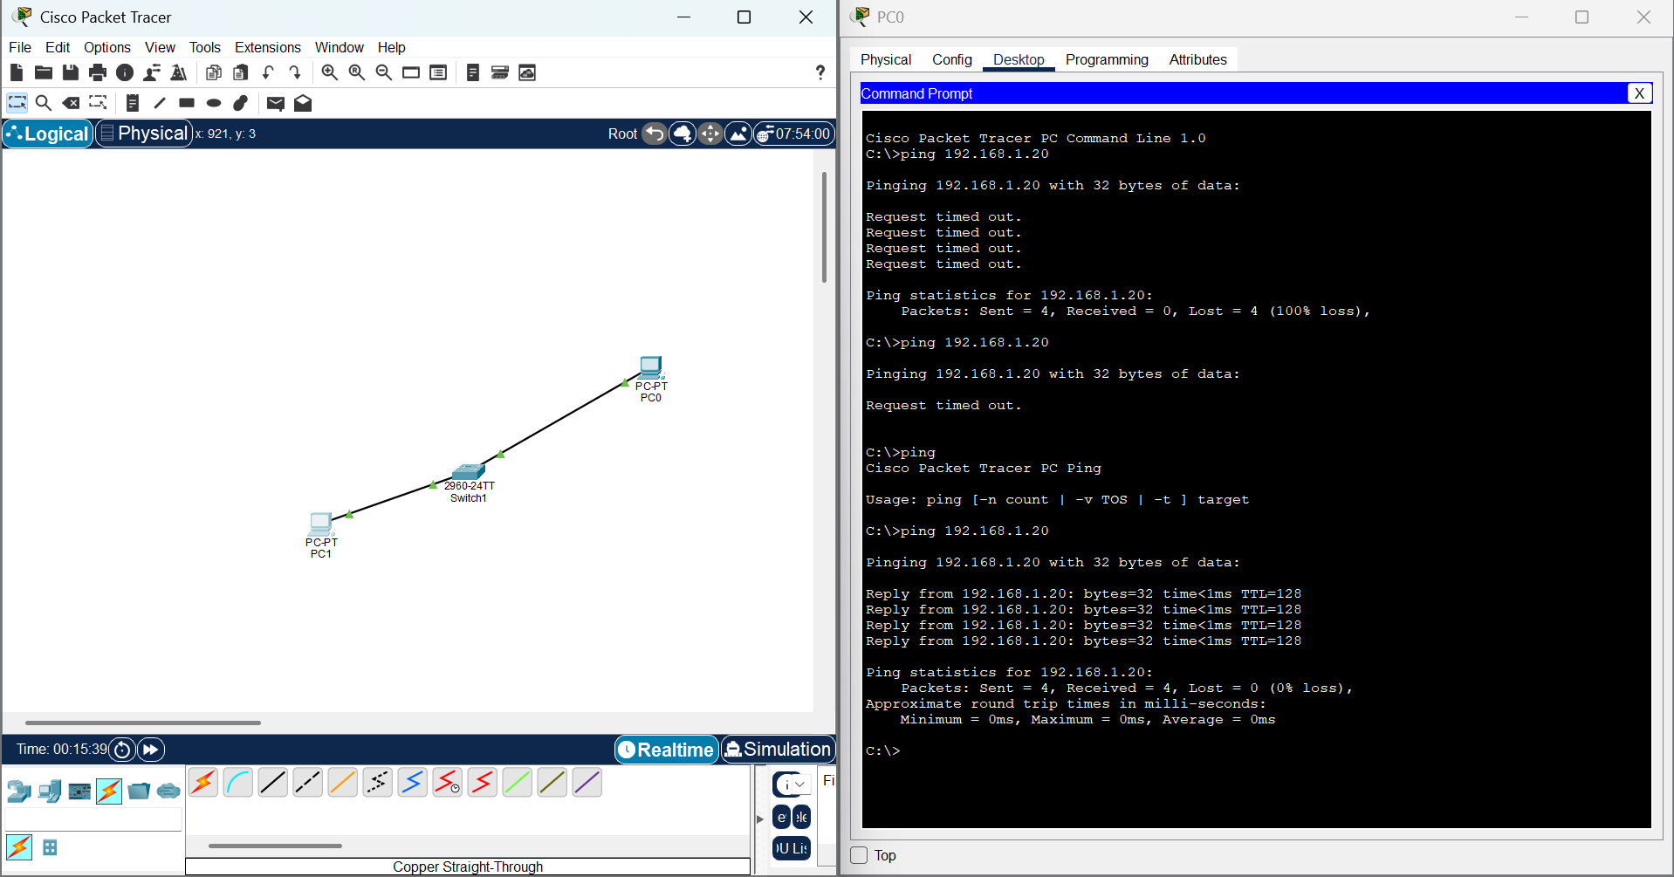

4).

ipconfig /release

ipconfig /renew

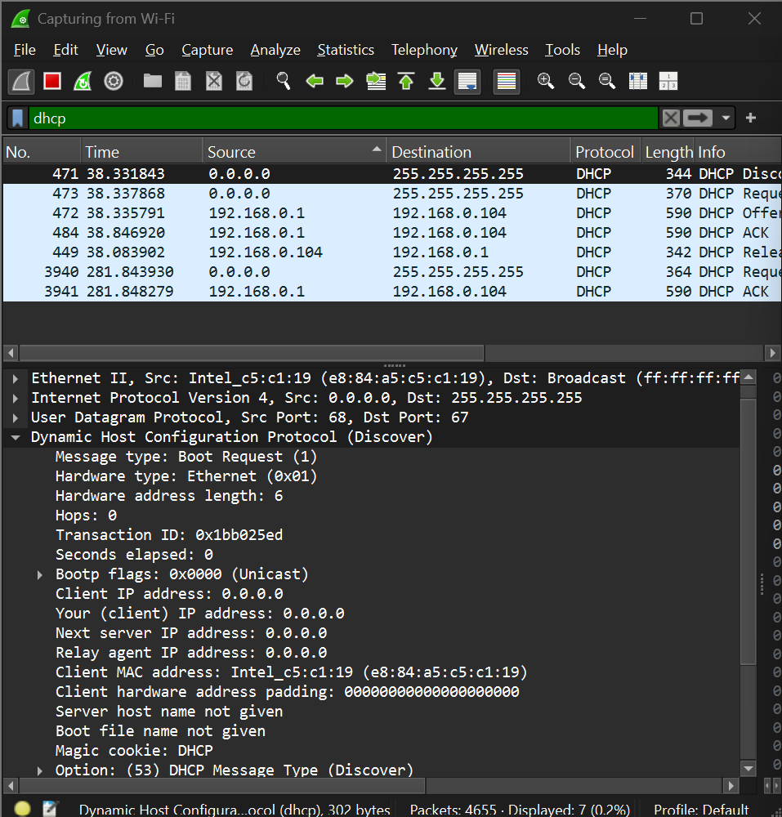

5).

**Original subnet:**

* + **192.168.1.0/24** → **255.255.255.0**
  + This provides **256 IPs** (0–255).

**Divide into 4 subnets:**

* + Each subnet should have **256 ÷ 4 = 64 IPs**.
  + The **new subnet mask** should allow 64 addresses per subnet.
  + The closest subnet mask that allows 64 IPs is **/26 (255.255.255.192)**.

**Calculate the Subnet Ranges**

With a **/26 subnet mask**, each subnet has **64** addresses:

| **Subnet** | **Network Address** | **Usable IP Range** | **Broadcast Address** |
| --- | --- | --- | --- |
| **Subnet 1** | 192.168.1.2/26 | 192.168.1.3 – 192.168.1.64 | 192.168.1.63 |
| **Subnet 2** | 192.168.1.66/26 | 192.168.1.67 – 192.168.1.128 | 192.168.1.127 |
| **Subnet 3** | 192.168.1.130/26 | 192.168.1.131 – 192.168.1.192 | 192.168.1.191 |
| **Subnet 4** | 192.168.1.194/26 | 192.168.1.195 – 192.168.1.254 | 192.168.1.255 |

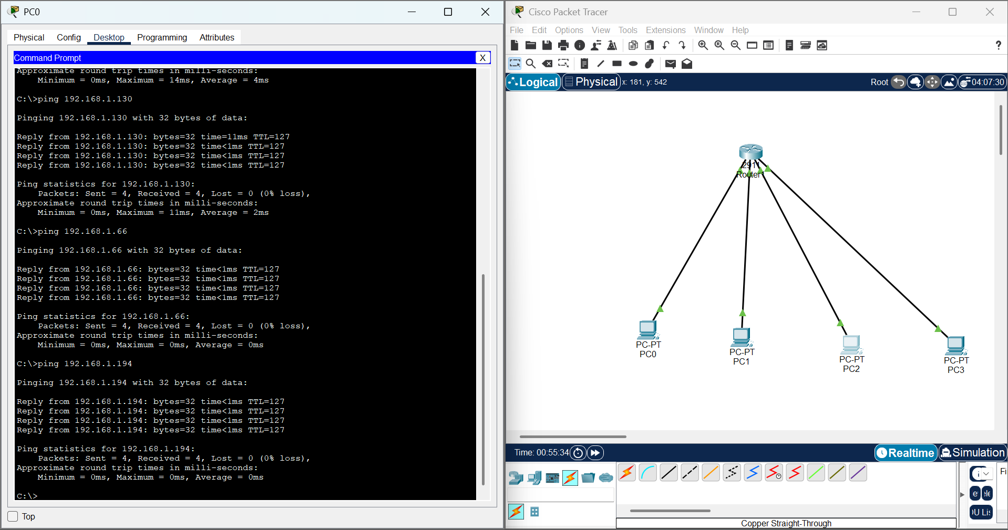

**6).**

| **ip address** | **Class** | **IP Address Range Class** | **Subnet Mask** |
| --- | --- | --- | --- |
| 10.1.1.1 | A | 0.0.0.0 - 127.255.255.255 | 255.0.0.0 |
| 172.16.5.10 | B | 128.0.0.0 - 191.255.255.255 | 255.255.0.0 |
| 192.168.1.5 | C | 192.0.0.0 - 223.255.255.255 | 255.255.255.0 |